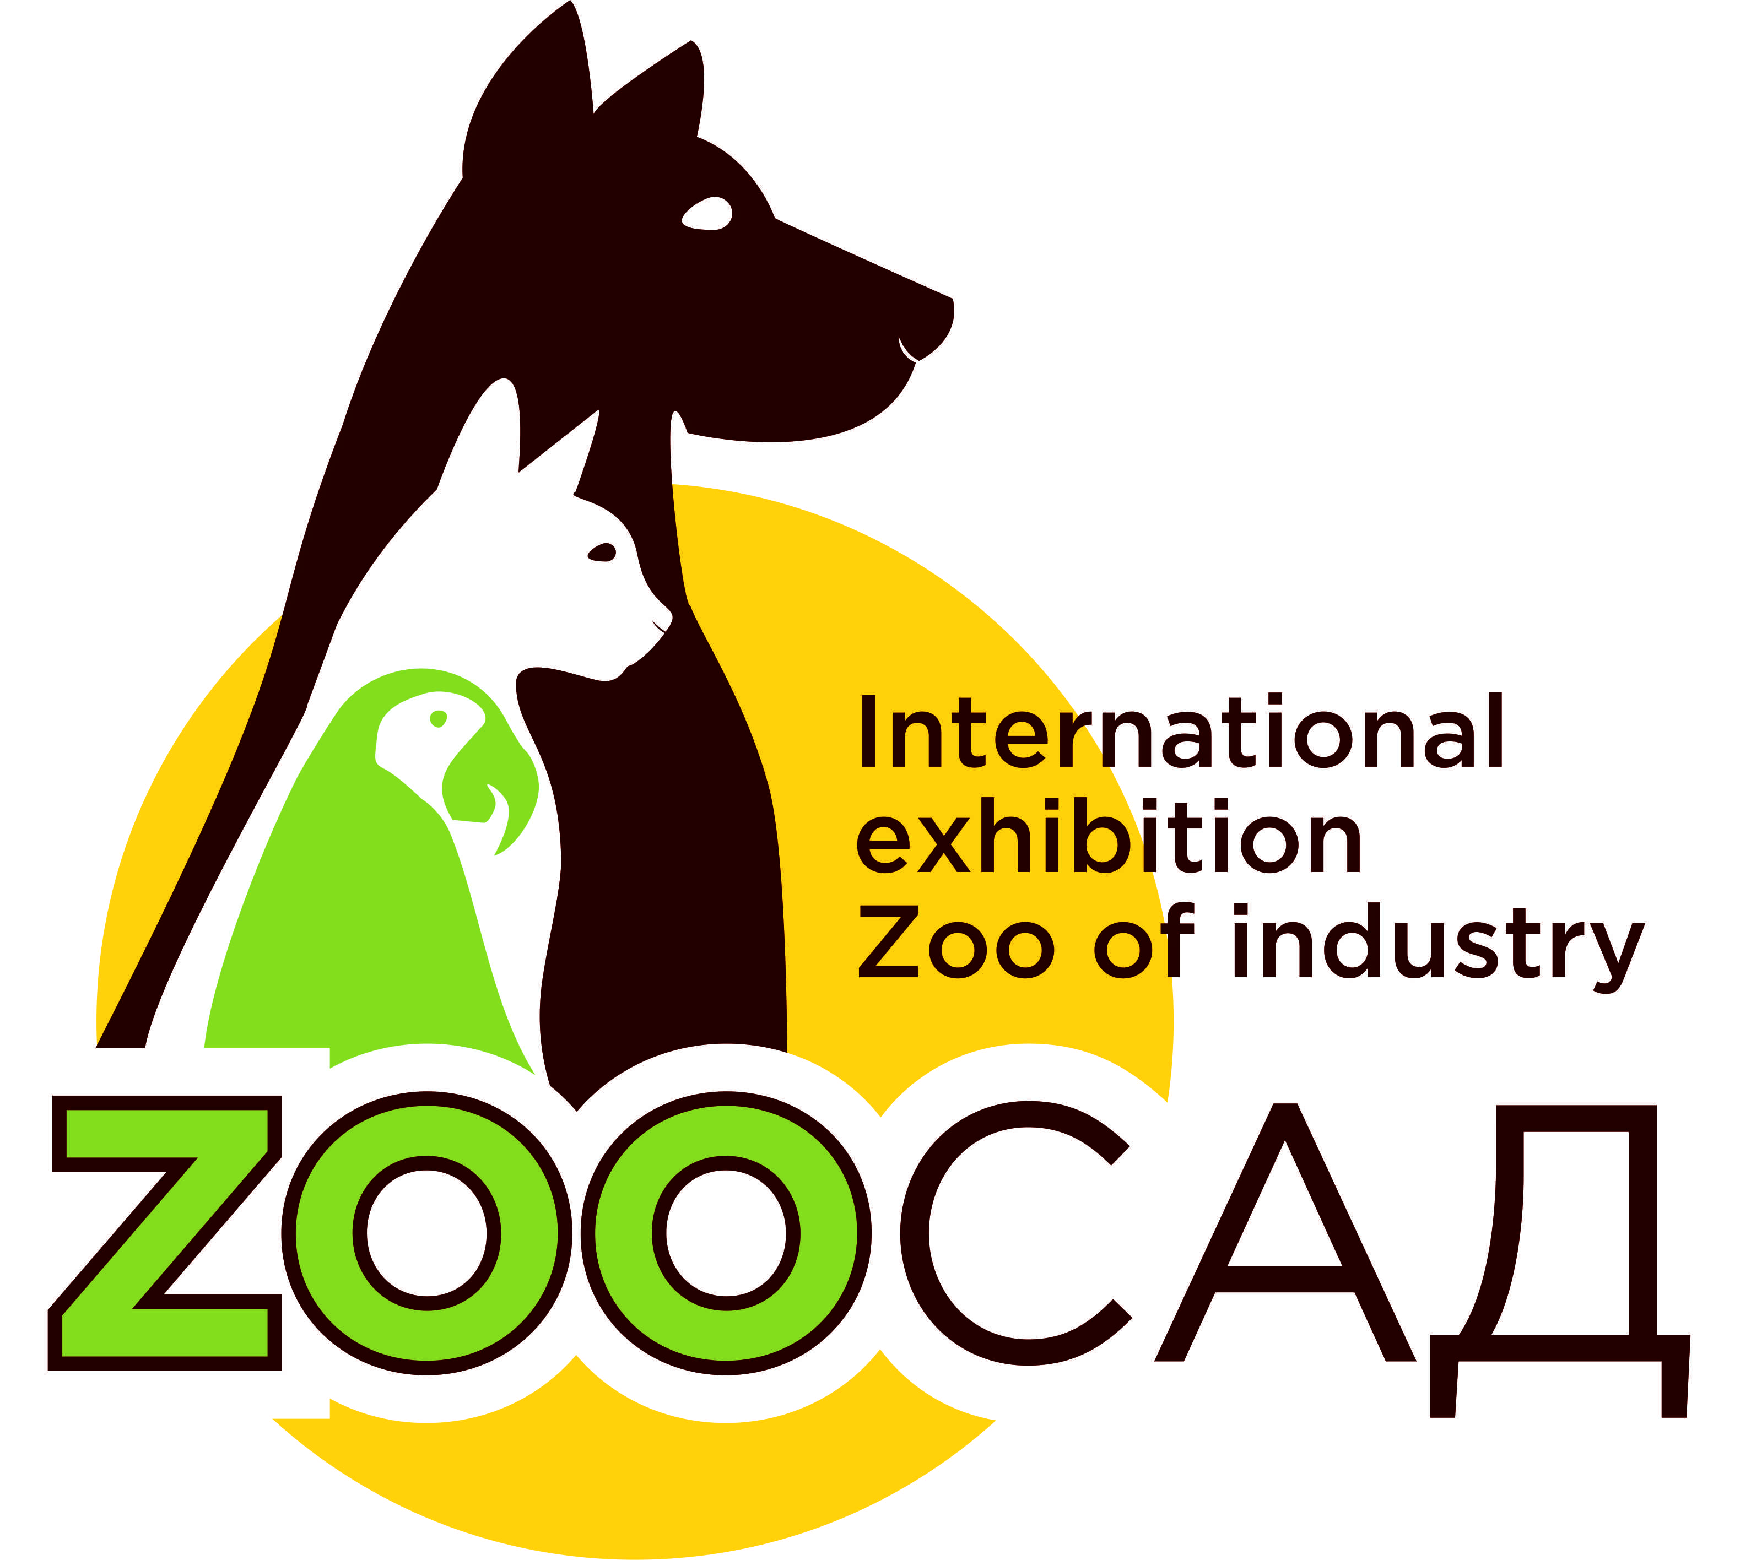

The package of proposals for Sponsors
Nominations
«Gold partner» , «Silver partner», «Bronze partner»

  - In order to maximize the commercial potential of the exhibition for your company, we offer you additional possibilities of creating an image of "Strong brand" within partner-sponsor programs on the "ZooGarden" exhibition.
  - It differentiates you from your competitors and allow you to introduce yourself to the wider market. The offer combines the exclusivity and priority; prestige and a wide range of action. The proposal will ensure high visibility of your company as a major player in the market, as well as provide an opportunity to make a significant impact on the target audience.

  - Exposition part:
  - • The right to promote yourself as a sponsor of the exhibition
  - • The right to promote yourself as a sponsor on the exhibition
  - • The right to design a stand as a "sponsor stand"

Advertisement of Sponsor in the exhibition business program:
  - • Distribution of advertising materials of the sponsor in the exhibition events (distribution packages, pens, samples, etc.)
  - • Presentation by representative of the official opening of the exhibition: advertising and welcome speech for 2-3 minutes.

The participation of the sponsor in the advertising campaign and mass media:
  - • Placement of the sponsor's logo on advertising materials
  - • Placement of text and sponsor's logo in the official exhibition catalog
  - • Placement of color Sponsor page (on the cover the catalog / inner page)
  - • Opening remarks in the official catalog of the exhibition with the mention of sponsorship

Special projects in the favor of the sponsor:
  - • Sertificate for sponsorship
  - We provide you the special opportunities that your company has decided to special tasks!
  - We will offer you the configuration of sponsorship proposals that will best match your marketing strategy!
  - Regarding to the cost of the partner-sponsorship packages, please contact:

  - Natalya Alexandrovna – project director
  - Elena Anatolievna – curator of the exhibition
  - Phone/Fax: +7 747 272 02 18, +7 707 251 77 51
  - E-mail: almatyzooexpo@gmail.com
  - www.zooexpo.kz

